Treasurer’s Report – July 1, 2014 – June 30, 2015
Southern Association for Counselor Education and Supervision

Checking Account
Balance as of July 1, 2014 $ 112.98
Revenue
Reg-online (conference) 114,402.49
Region Rebate from ACES 3,286.00
PayPal (dues) 7,827.09
Counter Deposit (conference) 6,026.80
Counter Deposits (dues) 370.00
$132,025.36
Expenditures
Birmingham Conference $80,952.73
Officer Expenses (conference) 3,834.73
Reg-online (merchant fee) 1,102.55
Social Justice Award 300.00
Officer Expenses (Site Visit) 1,000.23
Emerging Leaders 6,600.00
Awards 272.92
Jane Myers Memorial 100.00
Empty Plate Match 1,050.00
Website Management 3,506.00
Research Grants 5,000.00
Bank Wire Charges 43.00
$ 103,73616
Balance as of June 30, 2015 $ 28,263.20

Commercial Savings Account
Balance as of June 30, 2014 $ 81,589.73
Revenue
Interest Earned 45.89
$81,635.62
Balance as of June 30, 2015 $ 81.635.62

Amount transferred to new treasurer $109,898.82

SACES PayPal Account (Dues)
Balance as of June 30, 2015 $ 2,159.26

Total all SACES Accounts $ 112,058.08

Total all SACES Accounts as of July 1, 2014 $ 81,702.71
Total all SACES Accounts as of June 30, 2015 $112,058.08
Net gain for fiscal year $ 30,355.37

Respectfully Submitted

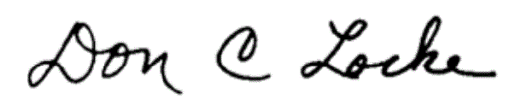
Don C. Locke, Treasurer 2014-15

